Two page project summary

*More in-depth analysis can be found in the Jupyter notebook.*

## Data

The data describes houses in the city of Ames in Iowa, USA. It consists of 1 460 observations and 81 variables. Each observation represents a different building. Judging by the city population (66 000), it can be assumed that the houses in this dataset represent a significant portion of all houses in this city. This dataset was created by taking all sales in the 2006 to 2010 period, and exported to Kaggle.

## Data manipulation

Since the dataset consist of a mixture of continuous, rank and categorical variables, we needed to start with some feature selection. After taking a quick look at the data, we decided to: drop all categorical variables with more than 2 levels, convert all remaining to binary. If any of them exhibited strong skewness, it was also removed. This allowed us to avoid using a large number of dummy variables. We also run a check on all columns, and dropped all that had a significant number of missing data.

## EDA

After data manipulation, we are left with 19 continuous and binary variables. All of them have good distributions, many displaying significant normality. 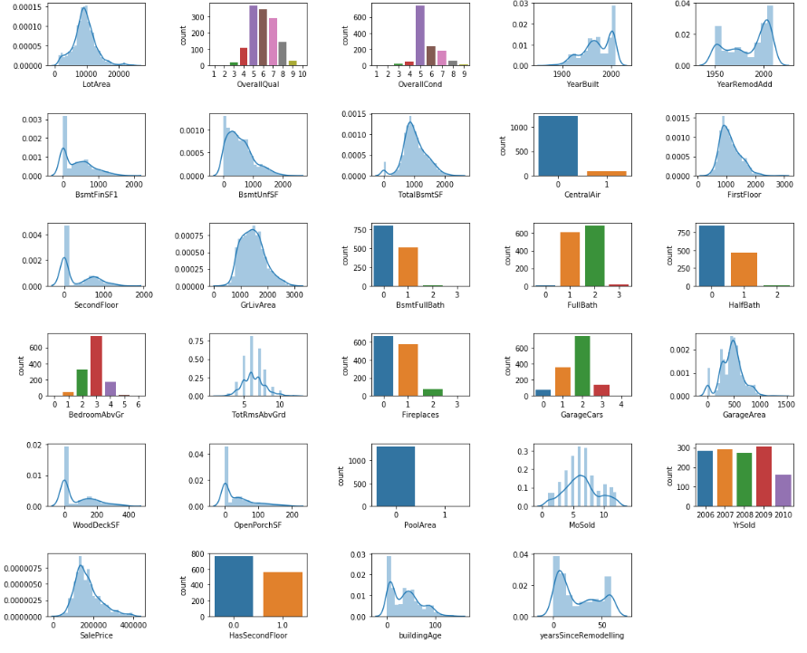

Some of the variables are correlated, both positively and negatively. This will need to be removed to perform OLS analysis, as leaving them can lead to unexpected results.

## Machine Learning Models

We decided to compare 4 machine learning methods – OLS, Ridge, Lasso and ElasticNet. We started with running basic OLS on all variables to get a glimpse into the data. We then run the OLS using cross validation, but it did not influence the results.

As a next step, we constructed a list on features that were the most significant in the previous OLS model. We also removed correlated variables. We then proceeded to run another OLS on this smaller set of features.

After this, we moved to more advanced models. We run Ridge, Lasso and ElasticNet on cross validation to estimate the alpha and ratio parameters.

In the end, we run all the final models and compared their predictive power using R^2. We also wrapped them into functions, and performed a simple 100 iteration time estimation using the timeit library.

## Findings

In the OLS model, we were left with 13 significant variables. All of them seem to be in line with the general wisdom – the price of the house is dependent on the area of the lot and the house, its condition and quality, its age and the time since a major remodeling. Having a central air conditioning and a fireplace seem to increase the value of the house substantially. Interesting are the wood deck and open porch variables – each square feet seem to increase the values substantially.

|  |  |  |
| --- | --- | --- |
|  | R^2 value | Time to run in seconds |
| OLS - correlation among variables | 0.8687 | 0.096 |
| OLS - with feature selection | 0.8625 | - |
| Ridge | 0.8618 | 0.116 |
| Lasso | 0.8598 | 0.211 |
| ElasticNet | 0.8616 | 0.474 |

The R^2 values of the estimated models are very similar. We were not able to achieve a significant increase in predicting power. But this is not the main feature of Ridge or Lasso. Their main benefit is the automatic feature selection, that was able to get rid of unwanted variables. This is reflected in the time that was needed to run this methods. Ridge seems to be nearly as fast as OLS, Lasso was around 100% slower, while ElasticNet was nearly 5 times slower.